

**Name of the Application**

July 14, 2017

|  |  |
| --- | --- |
| **Document Id:** | 1.2 |
| **Document Name:** | SC – Prepayment Automation Tool |
| **Publication Date:** | 12/07/2017 |
| **Latest Revision Date:** |  |
| **Prepared By:** | Swapnil Kulkarni |

|  |  |  |  |  |
| --- | --- | --- | --- | --- |
| **Version** | **Date** | **Change Mode**  **(C/A/M/D)** | **Brief description of change** | **Prepared/ Revised by** |
|  |  |  |  |  |
|  |  |  |  |  |
|  |  |  |  |  |
|  |  |  |  |  |

C – Created, A – Added, M – Modified, D – Deleted

**Table of Contents**

Table of Contents 3

1. Introduction 4

1.1. Purpose of the Document 4

1.2. Background 4

1.2.1. Current functionalities and limitations 4

2. Scope 5

2.1. Functional Requirements 5

3. Process Workflow – SOX 6

3.1. High Level Process Workflow 6

4. Role-Access Matrix 1

5. Sitemap 2

6. Login 3

6.1. Login 3

6.1.1. Business Rules 3

6.1.2. Wireframe 4

7. Email Notifications 5

7.1. Notification attached 5

8. Appendix 6

8.1. Prototype 6

8.2. Field Validation 6

8.3. Workflow 6

9. Approval Signature Page 7

# Introduction

## Purpose of the Document

The purpose of this document is to detail the functional design approach for “**APP**. This will be a web based application as a part of WNS SOX process which will have details of all the SOX checklist & Signoff process in WNS. It is expected the following groups of people will use this document:

* Business Sponsor and stakeholders will be expected to agree the requirements as stated within this document will meet their need.
* Solution Architects and Developers will be expected to agree to be able to deliver the requirements as stated within this document.
* Testers will base their test strategy and test cases on this document.

## Background

* Prepayments are amounts paid for by the business in advance of the goods or services being received for a future period.
* Therefore, prepaid expense must be not be shown as expense in the accounting period in which it is paid but instead it must be presented as such in the subsequent accounting periods in which the services in respect of the prepaid expense have been performed.
* At the end of an invoice specified period. The Prepaid expense account balance should be 0.
* The prepayment process applies where we have paid for services with Net Value £5000.00+.

## Scope of the document

* Input Form with validations / direct excel upload facility.
* O/P prepare prepayment schedule.
* Prepare customize reports as per the client requirement.

# Scope

## Functional Requirements

GUI Screen Prototype

1. **Login**

User will login to Application using username and password.

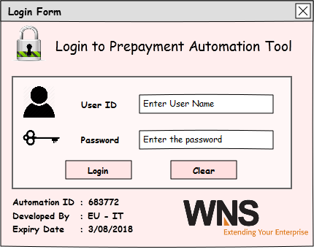

|  |  |  |  |  |
| --- | --- | --- | --- | --- |
| Field | Description | Mandatory (Y/N) | Control Type | Length |
| UserID | Enter user Name : admin | Y | Textbox | 5 |
| Password | Enter the password | Y | TextBox | 15 |

**Business Rules**

1. If either User ID or password field is kept blank, the Application shows error message for missing User ID or Password field.
2. Password field has been masked with * so that it will not disclose the confidential password.
3. On click of “Login” button Application validates if correct User ID and password is entered or not. If it is incorrect then Application will show message “Incorrect User ID/ Incorrect Password” however login form will be still visible to User.
4. Multiple attempts for login are allowed.
5. On successful login, “Prepayment Entry Form” should be shown.
6. On click of “Clear” button, the form will clear the contents of User ID and Password field.
7. If you close the login form then excel Application will be closed.
8. **Prepayment Entry Form:**

User can provide manual input into the database / Direct excel upload facility is also available whichever user feels comfortable, Generate Prepayment Schedule.

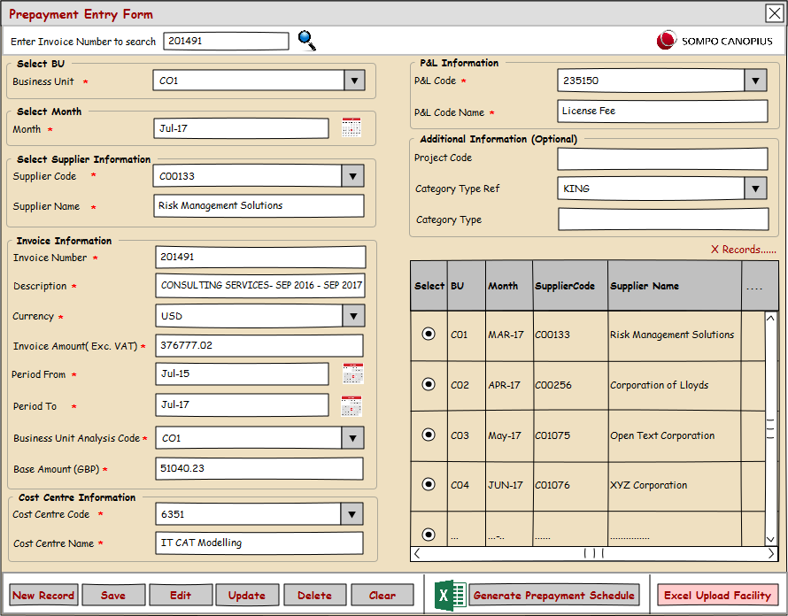

# Process Workflow

## High Level Process Workflow

# Login

## Login

.

### Business Rules

# Approval Signature Page

Deliverable Name: _____________________________________________

Version Number: _____________________________________________

Project Name: _____________________________________________

I agree that this document represents my best understanding of the information presented within this Deliverable for this project today. Future changes in this baseline document can be made through the project’s defined change process. I realize that approved changes might require us to renegotiate the costs, resource and schedule commitments for this project.

|  |  |  |  |
| --- | --- | --- | --- |
| **Name** | **Title** | **Signature / Electronic Vote / Email** | **Date** |
|  |  | <Approver Signature> | <Date Signed/Reviewed /Emailed> |
|  |  | <Approver Signature> | <Date Signed/Reviewed /Emailed> |
|  |  | <Approver Signature> | <Date Signed/Reviewed /Emailed> |
|  |  |  |  |
|  |  |  |  |